Wipro DSE MILESTONE- 1
Mini Project

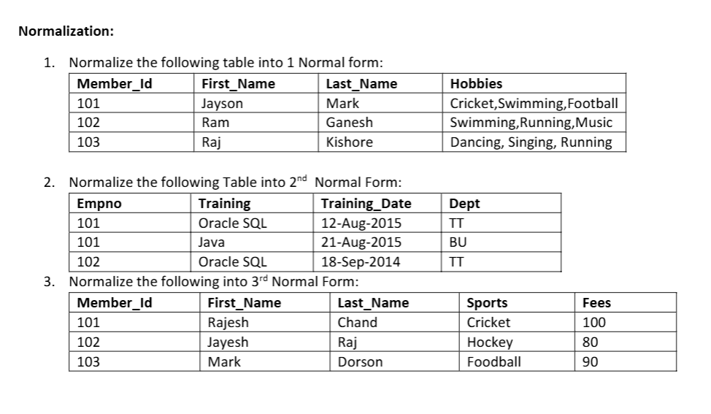

- Normalization in 1st NF:

Member_Id | First_Name | Last_Name | Hobby
101 | Jayson | Mark | Cricket
101 | Jayson | Mark | Swimming
101 | Jayson | Mark | Football
102 | Ram | Ganesh | Swimming
102 | Ram | Ganesh | Running
102 | Ram | Ganesh | Music
103 | Raj | Kishore | Dancing
103 | Raj | Kishore | Singing
103 | Raj | Kishore | Running

- Normalization in 2nd NF:
Employee Table-
Empno | Dept
101 | TT
102 | TT

Employee Training Table-
Empno | Training | Training_Date
101 | Oracle SQL | 12-Aug-2015
101 | Java | 21-Aug-2015
102 | Oracle SQL | 18-Sep-2014

- Normalization in 3rd NF:
Member table-
Member_Id | First_Name | Last_Name | Sports
101 | Rajesh | Chand | Cricket
102 | Jayesh | Raj | Hockey
103 | Mark | Dorson | Football

Sports Fees Table-
Sports | Fees
Cricket | 100
Hockey | 80
Football | 90

